Project Planning Phase
Project Planning Template (Product Backlog, Sprint Planning, Stories, Story points)
Date | 3 October 2026
Team ID | SWTID-2026-5226
Project Name | Import Data using Transform Maps (Spreadsheet)
Maximum Marks | 5 Marks
Product Backlog, Sprint Schedule, and Estimation (4 Marks)
Use the below template to create product backlog and sprint schedule
Sprint | Functional Requirement (Epic) | User Story Number | User Story / Task | Story Points | Priority | Team Members
Sprint-1 | Spreadsheet & Table Setup | USN-1 | As an administrator, I can create a Google Spreadsheet with sample employee data (Employee ID, Name, Email, Department, Location) and download it in .xlsx format. | 2 | High | Monika R
Sprint-1 |  | USN-2 | As an administrator, I can create a custom table, Employee Test (u_employee_test), and add the fields Employee ID, Employee Name, Email, Department and Location using Form Layout. | 3 | High | Priyanka D
Sprint-2 | Import Set Table & Transform Map | USN-3 | As an administrator, I can load the spreadsheet through Load Data to create the Import Set table Employee Import (u_employee_import). | 2 | High | Archana R K
Sprint-2 |  | USN-4 | As an administrator, I can create the Transform Map Sample Spreadsheet Import (source: Employee Import, target: Employee Test) and use Auto Map Matching Fields. | 3 | High | Archana R K
Sprint-2 |  | USN-5 | As an administrator, I can run the transform so that the staged data moves into the Employee Test table. | 1 | High | Archana R K
Sprint-3 | Transform, Validate & Coalesce | USN-6 | As an administrator, I can review the imported records in the Employee Test list and rearrange columns using Personalize List Columns to validate the data. | 3 | Medium | Priyanka D
Sprint-3 |  | USN-7 | As an administrator, I can enable Coalesce on the Employee ID field map so that duplicate records are not created. | 3 | High | Nithyasree M
Sprint-3 |  | USN-8 | As an administrator, I can load new data in Excel format into the import table (sheet number 1, header row 1) and run the transform again. | 5 | Medium | Pushpavalli B
Sprint-4 | Reports & Dashboards | USN-9 | As an administrator, I can create a pie chart report, Employees by Department, on the Employee Test table, grouped by Department with Count as the aggregation. | 3 | Medium | Pushpavalli B
Sprint-4 |  | USN-10 | As a report viewer, I can see the Employees by Department report on a dashboard. | 2 | Medium | Pushpavalli B

Project Tracker, Velocity & Burndown Chart: (4 Marks)
Sprint | Total Story Points | Duration | Sprint Start Date | Sprint End Date (Planned) | Story Points Completed (as on Planned End Date) | Sprint Release Date (Actual)
Sprint-1 | 5 | 6 Days
Sprint-2 | 6 | 6 Days
Sprint-3 | 11 | 6 Days
Sprint-4 | 5 | 6 Days
Velocity:
The team has 4 sprints of 6 days each, with 27 story points planned in total (5 + 6 + 11 + 5). Velocity = 27 / 4 = 6.75 story points per sprint. Let's calculate the team's average velocity (AV) per iteration unit (story points per day):
AV = velocity / sprint duration = 6.75 / 6 ≈ 1.13 story points per day
Burndown Chart:
A burn down chart is a graphical representation of work left to do versus time. It is often used in agile software development methodologies such as Scrum. However, burn down charts can be applied to any project containing measurable progress over time. The chart below shows the planned (ideal) burndown for the 27 story points across the four sprints.
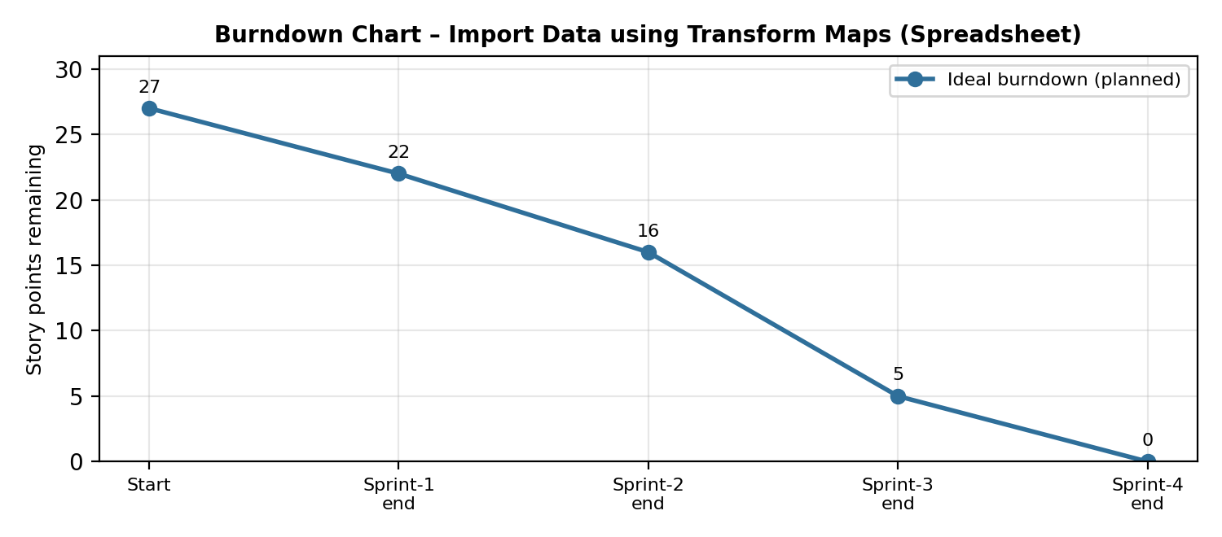
Reference:
https://www.atlassian.com/agile/project-management
https://www.atlassian.com/agile/tutorials/how-to-do-scrum-with-jira-software
https://www.atlassian.com/agile/tutorials/epics
https://www.atlassian.com/agile/tutorials/sprints
https://www.atlassian.com/agile/project-management/estimation
https://www.atlassian.com/agile/tutorials/burndown-charts

